Dear Parents and carers,

Membership subscription for Girlguiding

As your daughter / child is a member of Girlguiding UK you will be asked to pay subscription - this is split into 2 amounts:

- National membership fees, which are paid each February.
- Unit subs, which according to your unit, may be payable weekly, monthly or termly.

The Girlguiding UK membership fees cover the cost of supporting all our members, adult volunteers, and girls. It includes the costs of health and safety and meets the regulations that we have to comply with as a youth charity.
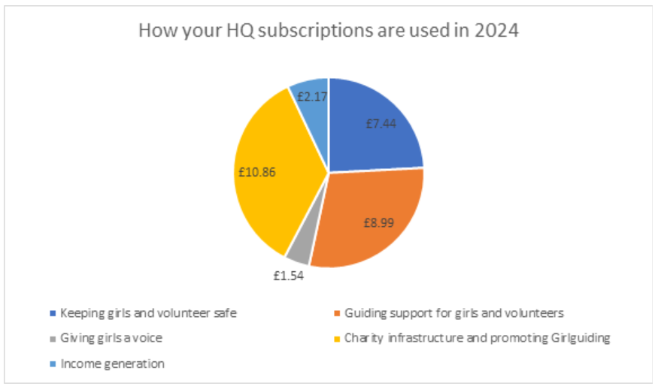

The Girlguiding UK costs goes towards:
  - Developing and maintaining our membership systems (GO, Join us).
  - Keeping the programme fun, fresh and easy to use so the girls enjoy it and learn through it.
  - Creating opportunities for girls to have adventures and international experience.
  - Training adults so that they have the skills to work with the young members.
  - Managing our e-learning platform.
  - Keeping policies and procedures up to date so everyone knows how to stay safe and within the law.
  - Providing child protection advice and support for volunteers so all members are safe.
  - Dealing with complaints, so that our standards are maintained.
  - Providing insurance for members and activities.
  - Managing disclosure check services for all volunteers.
  - Ensuring compliance with data protection and managing any issues.
  - Supporting our advocate panel which ensures the girls’ voices are heard.
  - Advertising and PR, so we can reach as many girls and adults as possible.
  - Managing our finances to make sure we make the best use of resources.
  - Managing our properties.
  - Running and improving the charity and supporting our board of trustees.
  - Applying for grants and fund raising.

At a national level, we work hard to raise money from other sources so we can give girls an even better experience while keeping the subs as low as possible. Our money also comes from donations and legacies, grants, our shops, our activity centers, and our investments.

Your unit subscription is used to pay for the activities that the girls do every week – such as craft materials, equipment, programme sheets, rent etc.

In 2025, the annual subscription is £55.50 plus the unit subscription, which is £XX . Therefore, from XX, you are required to pay £XX / per week / month / term.

Please transfer this amount to the following bank accounts on the following dates:
[insert your unit details here]

If you have any questions about this, or have any concerns about making these payments, please contact me.

Best wishes,

[Leader’s name and contact details]

