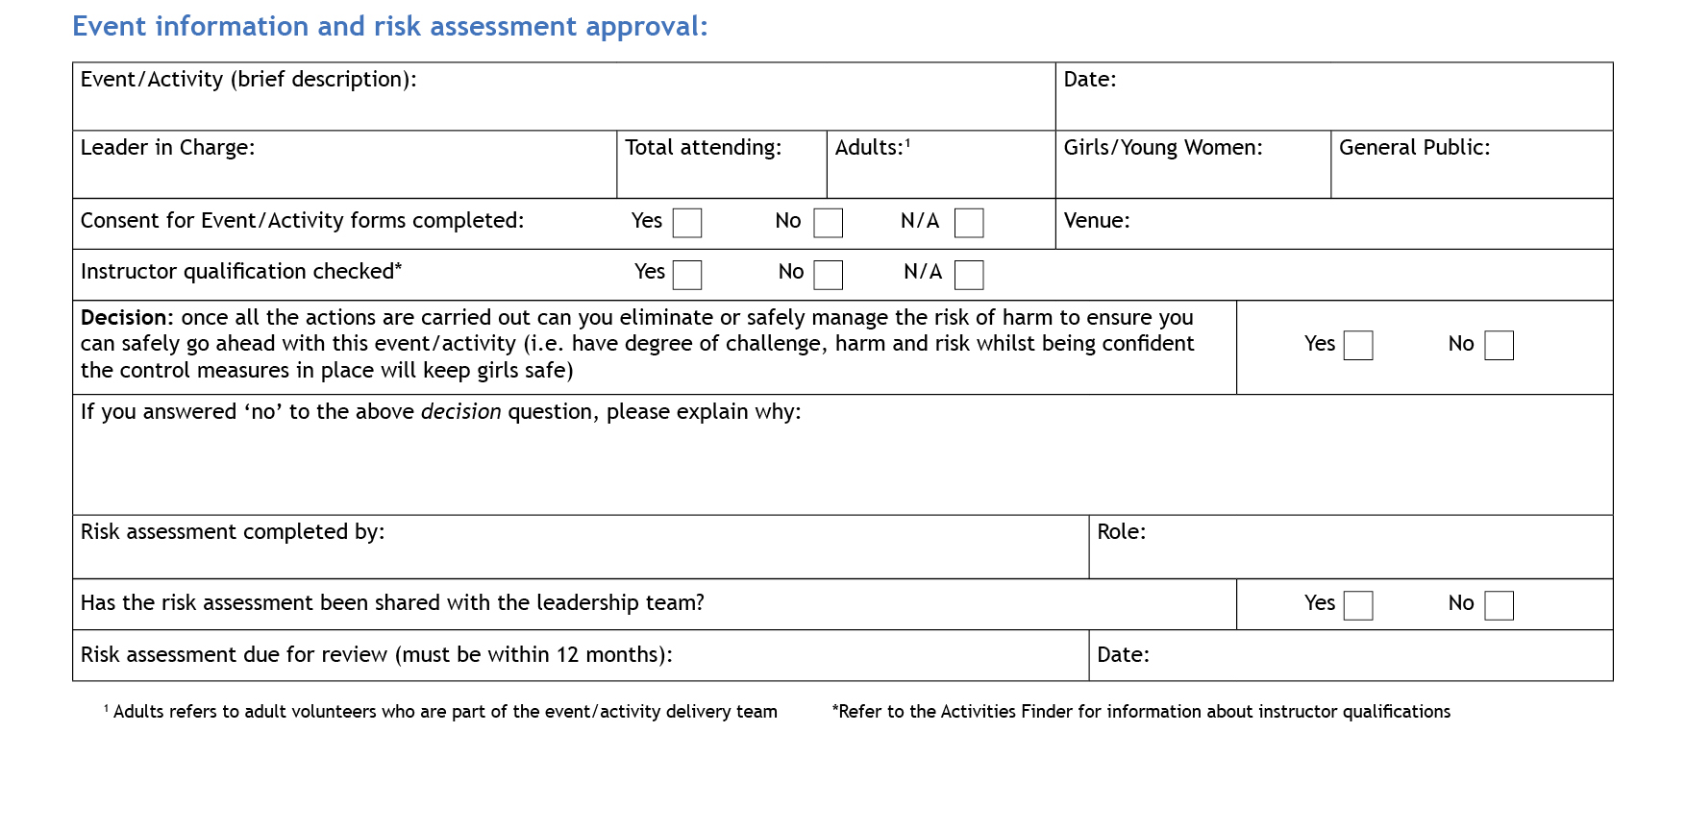
Please note that this is a generic risk assessment to be used as initial guidance in the operation of the silent disco activity and each leader, upon hiring the equipment from Girlguiding Lincolnshire South, should create their own risk assessment based on individual participant and venue information and share this with the leadership team.
Lisa Walker
Note that leaders running the activity should review and edit this risk assessment to factor in individual venue and participant circumstances.

County Guide Advisor/ Silent Disco Storer

X
X

At each hire event

0
Silent Disco
Hazards  What could cause harm or damage? | Who or what is at risk of being affected and how? | What are you already doing?  How have you reduced the risk already? | Likelihood  (L/M/H) | Severity of risk  (L/M/H) | Are further controls necessary?  What else needs to happen to reduce the risk to an acceptable level? | Action by:  name/date
Spread of illness via equipment – headsets | All participants | Use cleansing wipes to wipe down headsets between use by different individuals. Take care when doing so due to the moisture in the wipes and handling electronic equipment – do not get moisture in any ports/sockets. | L | L
Spread of illness through close vicinity | All participants | Consider having additional ventilation for the duration of the silent disco e.g. windows and/or doors open | L | L
ACTIVITY SPECIFIC
AREA / VENUE  Tripping/ slipping / falls  Bumps/bashes from participant collisions  Emergency procedures | All participants  All participants  All participants | Ensure any obstacles and tripping hazards are removed from the dancing area. Keep cables out of the way, barriered off or taped to the floor.  Adult supervision during silent disco to ensure appropriate behaviour. Wearing headsets can reduce special awareness so ensure plenty of space for the participants in the venue.  Ensure leaders understand how to stop all music quickly in the case of needing to implement emergency procedures. | M  M  L | L  L  H
EQUIPMENT  Electrocution  Hearing loss through high volume  Injury through lifting of equipment boxes  Dehydration / dizziness  Damage to equipment | All participants  All participants  Leaders  All participants | Keep charging sockets out of reach of young members. Use socket blanks for empty sockets where possible. Ensure all equipment appears to be in good working order before use. Keep equipment dry.  Participants can control the volume on individual headsets. Encourage a lower volume listening. Keep audio input sources on lower volumes.  Always lift in a safe way and pack boxes away according to contents instructions to avoid overloading weight.  Ensure participants have access to a drink during the silent disco to keep hydrated. Open windows to cool area down if it gets hot.  Supervision of participants whilst using equipment. Check equipment looks to be in good working order before handing out. | L  L  L  L  L | M  L  M  L  L | Adults only to use cleansing wipes on equipment.  Boxes can be carried as a pair to reduce weight.  Keep drinks away from electronic equipment.  Report any damaged equipment to Lisa Walker

Update your risk assessment to take into account the latest health advice around self-isolation rules
Make sure you would have measures in place (agreed with parents) in case pupils or trip supervisors show symptoms and need to self-isolate
Listen to advice from your provider(s) for travel insurance and public liability insurance – if they say cancel, follow their advice
Gather the opinions of parents, pupils and staff – check what the views are on the playground and in the staff room

Commissioner’s signature: …………………………………………………………………………………… Date: …………………………………

