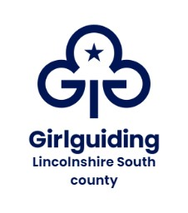

**Rainbows Christmas Challenge FAQ’s**

**What is the Rainbows Christmas Challenge?**

Created by Lincs South County it’s Christmas in a box, designed specifically for Rainbows, to be held locally by units in December 2023.

As it’s hard to take Rainbows to a large-scale county event we wanted to do something for them that can be held locally. In a similar vein to the Super Rainbows event run by Anglia region in 2022.

Your Rainbows Christmas Challenge boxes will have the resources needed to complete Christmas themed craft activities, additional resources and there will be further resources available to access online.

The team behind the project have worked hard to keep the cost of the boxes to £10 per unit, to ensure it is accessible to all units.

**How can I order a Rainbows Christmas Challenge box?**

Boxes are now available to order [here](https://forms.gle/XurAVmsvCsZieVnn9).

You will be sent an invoice once you have ordered and your box will be secured once your payment is complete.

Please order for the number of Rainbows you anticipate having in December 2023.

The closing date for orders is Friday 20th October 2023.

You can also add on any additional badges for leaders on the order form.

**When will we receive the boxes?**

We anticipate that the boxes will be shipped out over the last week in November so that units have them ready for December.

**How can I share with you all the amazing things we are doing with our boxes?**

Either; email us at [info@gglincssouth.org](mailto:info@gglincssouth.org) or use our Tell Us page on the website [here](https://girlguidinglincolnshiresouth.org/homepage/member-information/tell-us/).

You can also share with us on our closed members only county Facebook group [here](https://www.facebook.com/groups/622116132097274).

Please ensure you have the correct permissions for sharing the photos. Our County Photo Permission Form can be found on our website [here](https://girlguidinglincolnshiresouth.org/homepage/member-information/forms/).

