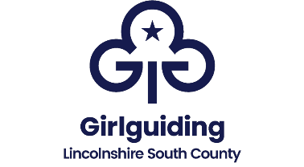

Lincolnshire South county
Badge and standard order form
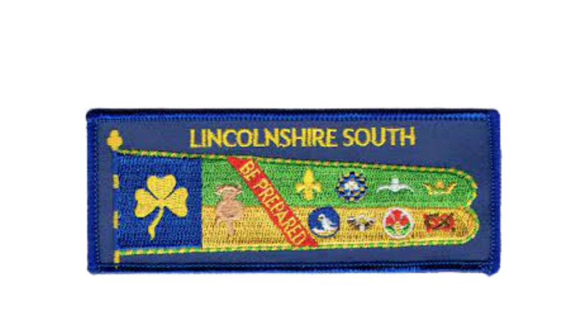

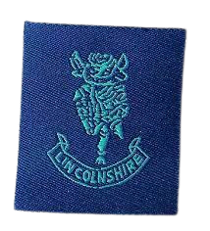
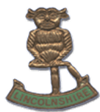

Cloth County Badge
Metal County Badge
County Standard

Badge | Price | Quantity
County standard woven badge | £1.00
County badge – Metal | £2.50
County badge – Cloth | £0.20

*Postage and packing will be added to your invoice

Contact name and address (and unit if applicable):

Email (in case of query):

Send your order form via email to: badgesecretary@gglincssouth.org

