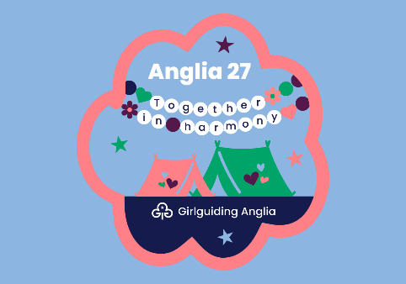
Anglia 27 Region camp
When: Saturday 7 – Friday 13 August 2027
Where: Hautbois Activity centre, 5 Great Hautbois Rd, Coltishall, Norwich NR12 7JN
Who: Guides and Rangers from Girlguiding Anglia Region
We are bringing you an inclusive and vibrant experience where every individual feels connected, valued, and inspired. With a focus on bringing members together in a spirit of unity and joy, offers endless opportunities for fun, laughter, and shared experiences.

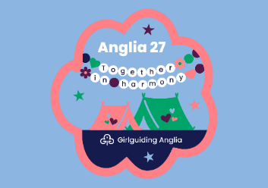
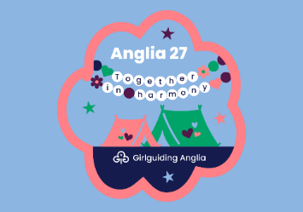
Cost:
£350pp
What's included:
Transport to and from the event by coach
• 6 nights camping
• Breakfast, lunch, dinner, drinks and snacks throughout the event
• Adventurous activities
• Craft and wellbeing workshops
• Evening entertainment
Girls will take part in four exciting activity sessions each day, with each session lasting 1 hour and 30 minutes. Girls will take part in activities in groups of 16, creating a great opportunity to build teamwork, confidence, and lasting friendships throughout the week.
The programme offers a fantastic and varied mix of experiences, carefully balanced across the week. Activities include adventurous challenges at Hautbois, traditional camp skills, wellness sessions, creative artisan crafts, and music and drama.
And for the first time ever at a Girlguiding Anglia event, there will also be an exciting trip off-site.

Girls from our County will all camp together with leaders provided by the County Adventure Team lead by Sue Wheelwright.
There will be chances to meet up and get to know the leaders and other attendees before the event.
Please contact the adventure team adventure@gglincssouth.org to apply for a place or for more information..
Places will be offered on a first come first served basis.
A £50 non-refundable deposit will be required to confirm a place followed by 3 further payments of £100. Payment information will be provided once your place is confirmed.
Bookings will be made via the County Adventure Team and not by individual members/units.

